|  |
| --- |
| **Exp No: 1- A**  **Date: 29/ 11/22** |

**STUDENT GRADE ANALYSIS**

**Aim:**

To draw flowchart and write algorithm for the following problem.

**ALGORITHM:**

**STEP 1:** Start.

**STEP 2:** Get the Number of students (N)

**STEP 3:** Assign i = 0.

**STEP 4:** Check for the condition i < N.

**4.1:** If True, Get Name, Roll.no and Marks m1, m2, m3, m4, m5.

**4.2:** Calculate Total = m1 + m2 + m3 + m4 + m5 and Average = Total / 5

**4.3:** Display Name and Roll Number.

**4.4:** Check for condition avg >= 30 and avg < 50.

**4.4.1:** If True Display the message your grade is c" and increase i value by 1.

**4.5:** Check for condition avg > 50 and avg < 80

**4.5.1:** If True Display the message "You grade is B" and increase i value by 1.

**4.6:** Check for the condition avg > 80 and avg ≤ 100

**4.6.1:** If True Display the message. "Your grade is A" and increase i value by 1.

**4.7:** Check for the condition avg < 30

**4.7.1:** If True Display the message "Your grade is D".

**STEP 5:** If False, goto step 6

**STEP 6:** Stop.

**FLOWCHART:**

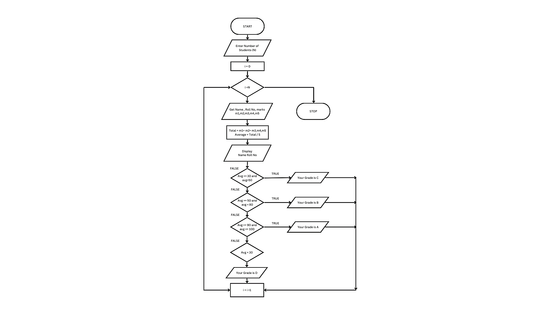

**Pseudo code:**

BEGIN

GET the Number of students (N)

ASSUME i= 0

IF i < N

GET Name, Roll.no and Marks m1, m2, m3, m4, m5.

CALCULATE Total = m1 + m2 + m3 + m4 + m5 and Average = Total / 5

DISPLAY Name and Roll Number

ENDIF

IF avg >= 30 and avg < 50.

DISPLAY “ your grade is c”

INCREMENT i value by 1

ELIF avg > 50 and avg < 80

DISPLAY"You grade is B"

INCREMENT i value by 1

ELIF avg > 80 and avg ≤ 100

DISPLAY "Your grade is A"

INCREMENT i value by 1

ELIF avg < 30

DISPLAY "Your grade is D".

ELSE goto end

END

**RESULT:**

Thus, the algorithm and flowchart are written for the given problem.

|  |
| --- |
| **Exp No: 1- B**  **Date: 29/ 11/22** |

**CALCULATING ELECTRIC BILL**

**AIM:**

To draw flowchart and write algorithm for calculating the electric bill.

**ALGORITHM:**

**STEP 1:** Start.

**STEP 2:** Enter Current Unit (CU).

**STEP 3:** Enter Old Unit (OU).

**STEP 4:** Calculate N = CU - OU

**STEP 5:** Check for the condition N<=100 If true.

**5.1**: Calculate E.C using formula. FC = 0, DC = 0, EC= 0

**5.2:** Calculate the Total charges = FC + DC + EC

**5.3:** Display amount needed to pay and go to stop.

**STEP 6:** Check for condition N<=200 If true.

**6.1**: Calculate E.C using formula FC = 20, DC = 18, EC = (N – 100) * 1.5

**6.2:** Calculate the Total charges = FC + DC + EC

**6.3:** Display amount needed to pay and go to stop.

**STEP 7:** Check condition N<=500 of take.

**7.1:** Calculate EC using formula. FC = 73, DC = 48, EC = ( N - 100) * 3.5

**7.2:** Calculate the Total charges = FC + DC + EC

**7.3:** Display amount need to pay and go to stop.

**STEP 5:** Check for the condition N>500 If true.

**5.1:** Calculate the E.C using FC=75, DC=100, EC = (400 * 4.5) + (N - 500) * 6

**5.2:** Calculate Total charges = FC + DC + EC

**5.3:** Display the amount need to pay and go to stop

**STEP 7:** Stop.

**FLOWCHART:**

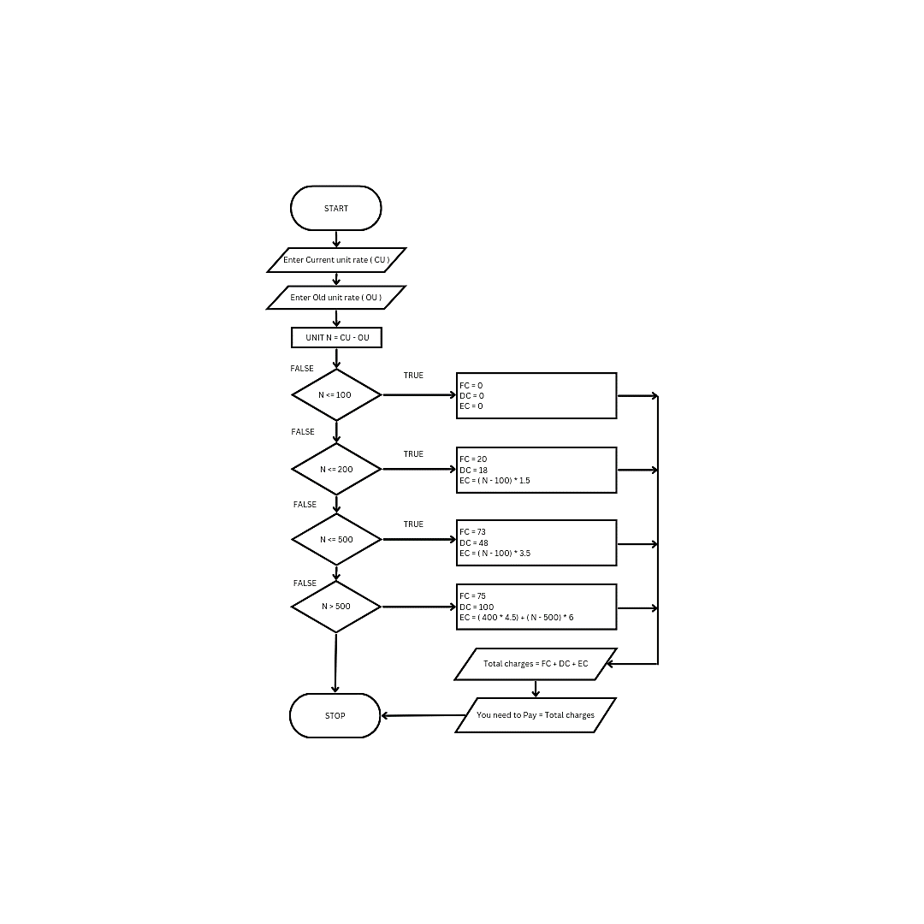

**PSEUDO CODE:**

BEGIN

ENTER Current Unit (CU).

ENTER Old Unit (OU).

CALCULATE N = CU - OU

IF N<=100

CALCULATE E.C using formula. FC = 0, DC = 0, EC= 0

CALCULATE the Total charges = FC + DC + EC

DISPLAY amount needed to pay and go to end

ELIF N<=200

CALCULATE E.C using formula FC = 20, DC = 18, EC = (N – 100) * 1.5

CALCULATE Total charges = FC + DC + EC

DISPLAY amount needed to pay and go to end

ELIF N<=500

CALCULATE FC = 73, DC = 48, EC = ( N - 100) * 3.5

CALCULATE the Total charges = FC + DC + EC

DISPLAY amount need to pay go to end

ELSE N>500 If true.

CALCULATE E.C using FC=75, DC=100, EC = (400 * 4.5) + (N - 500) * 6

CALCULATE Total charges = FC + DC + EC

DISPLAY the amount need to pay go to end

ENDIF

END

**RESULT:**

Thus, the algorithm and the flowchart is written for the given problem.

|  |
| --- |
| **Exp No: 1- C**  **Date: 29/ 11/22** |

**CALCULATE WEIGHT OF IRON ROD**

**AIM:**

To draw flowchart and write algorithm for calculating the weight of a steel Rod.

**ALGORITHM:**

**STEP 1:** Start.

**STEP 2:** Get the number of Iron nods.

**STEP 3:** Initialize the value I and weight as 0.

**STEP 4:** Chock for the condition i = n.

**4.1:** of true, get the diameter of the rod.

**4.2:** Calculate the weight-unit-weight using the formula d*2 /162 = W

**4.3:** Calculate the weight using the formula.

No. of rods x weight - Tw

**4.4:** Calculate total weight = TW+W.

**4.5:** Increment the value of i by 1 goto step 4.

**4.1:** If false display the total weight.

**STEP 5:** Stop

**FLOWCHART:**

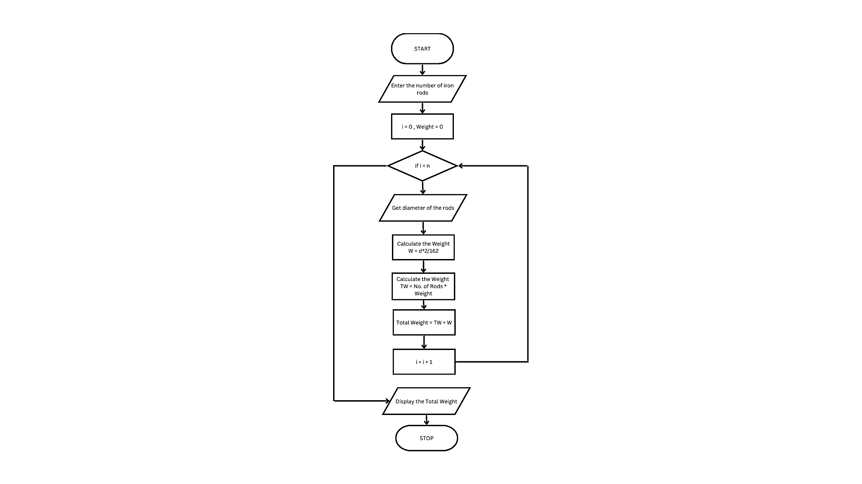

**PSEUDO CODE:**

BEGIN

GET the number of Iron nods

INITIALIZE the value I and weight as 0

FOR i = n

GET the diameter of the rod.

CALCULATE the weight-unit-weight using the formula d*2 /162 = W

CALCULATEthe weight using the formula

No. of rods x weight - Tw

CALCULATEtotal weight = TW+W.

INCREMENT i by 1

END FOR

DISPLAYthe total weight.

END FOR

END

**RESULT:**

Thus, the algorithm and the flowchart is given for the problem.

|  |  |
| --- | --- |
| **Exp No: 1- D**  **Date: 29/ 11/22** | **CALCULATE WEIGHT OF A MOTORBIKE** |

**AIM:**

To draw flowchart and write algorithm for calculating weight of a motorbike.

**ALGORITHM:**

**STEP 1:** Start.

**STEP 2:** Get gross vehicle weight Rating GVWR

**STEP 3:** Get Dry weight (DW)

**STEP 4:** Get Fuel weight (FW)

**STEP 5:** Get Raider weight (RW)

**STEP 6:** Get Passenger weight (PW)

**STEP 7:** Calculate Total weight = DW+FW+RW+PW

**STEP 8:** Get Load.

**STEP 9:** Calculate safe weight. GVWR-Load-weight.

**STEP 10:** Check the condition safe weight >=0.

**10.1:** If true, print the message “You have a safe load and you can drive" goto stop.

**10.2:** If false, print the message "Reduce the load and then drive”.

**10.2.1:** GOTO step 8.

**STEP 11:** Stop.

**FLOWCHART:**

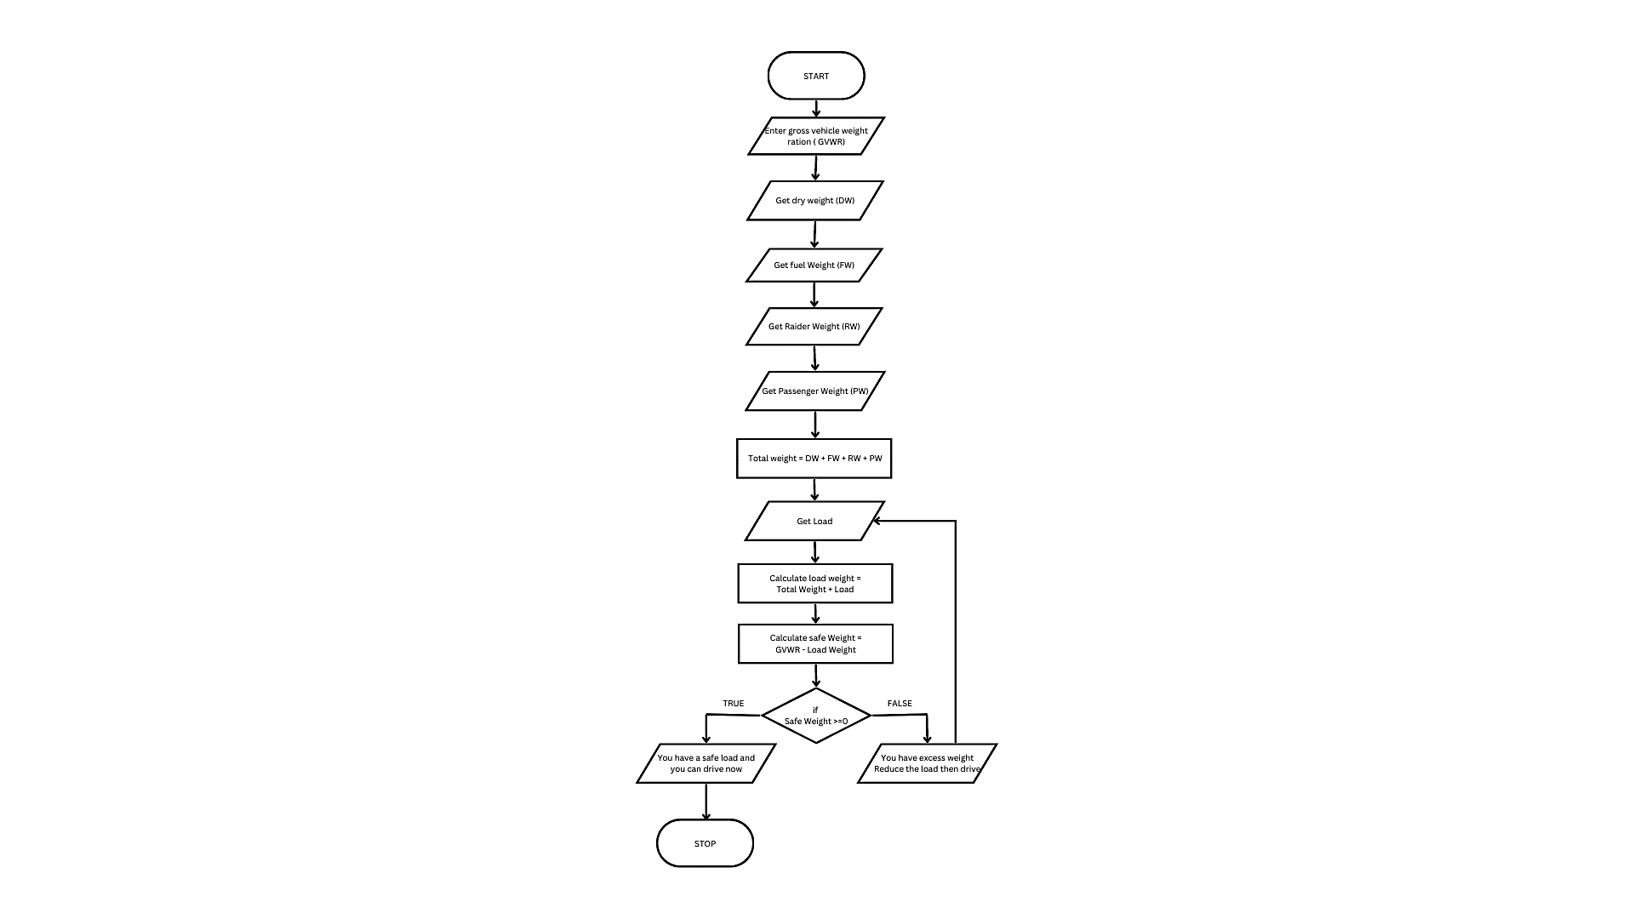

**Pseudo code:**

BEGIN

GET gross vehicle weight Rating GVWR

GET Dry weight (DW)

GET Fuel weight (FW)

GET Raider weight (RW)

GET Passenger weight (PW)

CALCULATE Total weight = DW+FW+RW+PW

GET Load

CALCULATE safe weight. GVWR-Load-weight

IF safe weight >=0

PRINT “You have a safe load and you can drive" goto stop

ELSE

PRINT "Reduce the load and then drive”

GET load

ENDIF

END

**RESULT:**

Thus, the flowchart and the algorithm is written for the problem.

|  |  |
| --- | --- |
| **Exp No: 1- E**  **Date: 29/ 11/22** | **CALCULATE ELECTRIC CURRENT IN**  **3 PHASE A/C CIRCUIT** |

**AIM:**

To draw flowchart and write algorithm. to- calculate electrical current in 3 phase AC circuit.

**ALGORITHM:**

**STEP 1:** Start

**STEP 2:** Get value of pf (power factor)

**STEP 3:** Get value of Current (I).

**STEP 4:** Get value of voltage (V)

**STEP 5:** Calculate P using the formula P= √3*pf*I*V.

**STEP 6:** Display the value of P.

**STEP 7:** Stop

**FLOWCHART:**

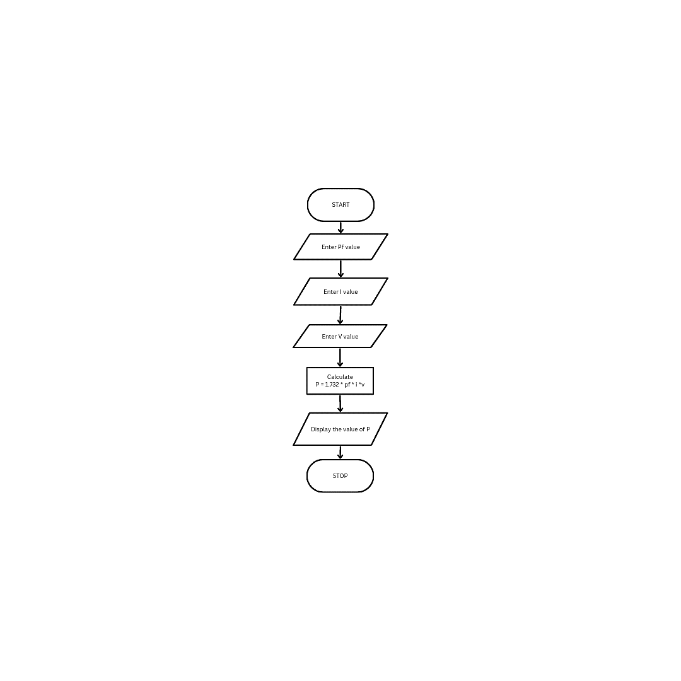

**PSEUDO CODE:**

BEGIN

GET value of pf (power factor)

GET value of Current (I)

GET value of voltage (V)

CALCIULATE P using the formula P= √3*pf*I*V

DISPLAY the value of P

END

**RESULT:**

Thus the flowchart and the algorithm is written for the given problem.

**EXP NO:1-F RETAIL SHOP**

**DATE:29/11/22**

**AIM:**

To draw the flowchart and write the algorithm for the retail shop billing.

**ALGORITHM:**

**STEP 1:** Start

**STEP 2:** Get the Bill number.

**STEP 3:** Get costumer Customer name and phone number

**STEP 4:** Get the value of total No. of Items purchased.

**STEP 5:** Initialize the values for i =0, Total =0, Net Amount = 0 and Gross=0.

**STEP 6:** Check if condition i<=n.

**6.1:** If true, get Item name, Price, Quantity and the discount.

**6.2:** Calculate the Gross = Price * quantity

Calculate the Disc = Gross * Discount%

Calculate the Net Amount = Gross-Disc

**6.3:** Calculate the Total = Total + Net Amount.

**6.4:** Increment the value of i and goto step 6.

**STEP 7:** If False, get the GST value.

**STEP 8:** Calculate GST Amount = ( Gross * GST% ) / 100.

Calculate the BILL Price = Net Amount + GST Amount

**STEP 9:** Display the Bill Amount

**STEP 10:** Stop.

**FLOWCHART:**

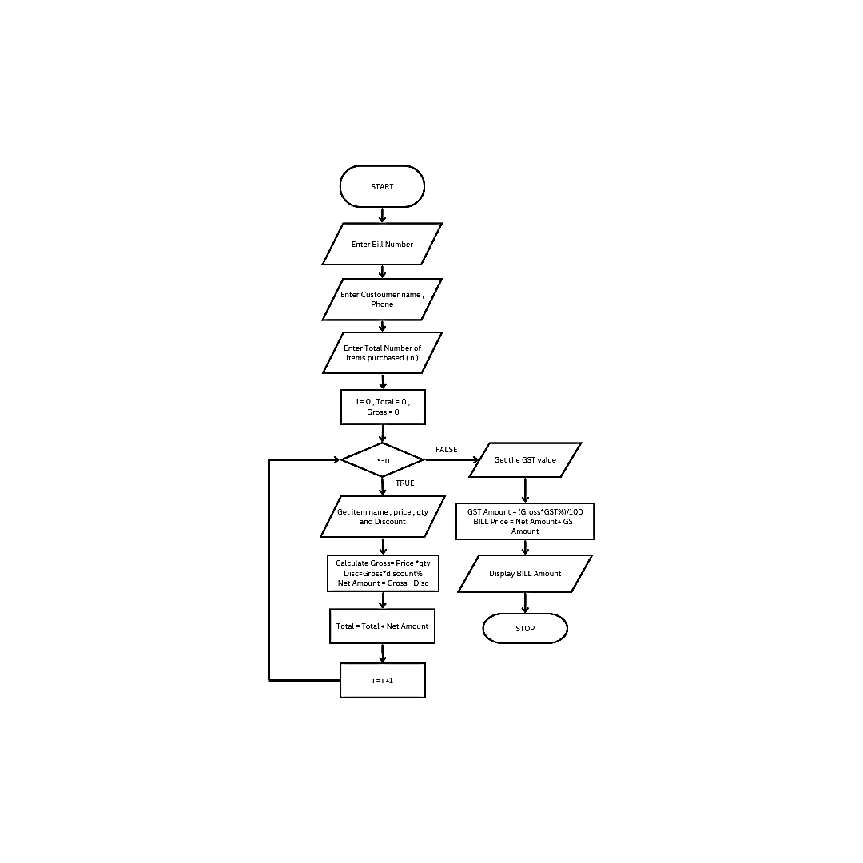

**PSEUDO CODE:**

BEGIN

GET the Bill number

GET costumer Customer name and phone number

GET the value of total No. of Items purchased

INITIALIZE the values for i =0, Total =0, Net Amount = 0 and Gross=0

FOR

IF i<=n

GET Item name, Price, Quantity and the discount

CALCULATE the Gross = Price * quantity

CALCULATE the Disc = Gross * Discount%

CALCULATE the Net Amount = Gross-Disc

CALCULATE the Total = Total + Net Amount.

INCREMENT the value of i

ELSE

get the GST value

END IF

END FOR

CALCULATE GST Amount = ( Gross * GST% ) / 100

CALCULATE the BILL Price = Net Amount + GST Amount

DISPLAY the Bill Amount

END

**RESULT:**

Thus, the flowchart and the algorithm is written for the problem

|  |  |
| --- | --- |
| **Exp No: 1- G**  **Date: 29/ 11/22** | **SINE SERIES.** |

**AIM:**

To draw flowchart and write algorithm for the sine series.

**ALGORITHM**:

**STEP 1:** Start.

**STEP 2:** Get the value of x.

**STEP 3:** Initialize the values of 1=1, sine =0 and import moth.

**STEP 4:** Get the value of N.

**STEP 5:** Check weather value do i less than N

**5.1:** If condition is true, convent a to radians and adding it to y.

**5.1.1:** Let value of s be (-1) to the power i

**5.1.2:** Now calculate the series using the formula.

Sine = sine + ((y**2* i +1))/ math factorial (21+4) S.

**5.1.3:** Increment value of i by 1.

**5.2**: If condition is false display sine.

**STEP 6:** Stop.

**FLOWCHART:**

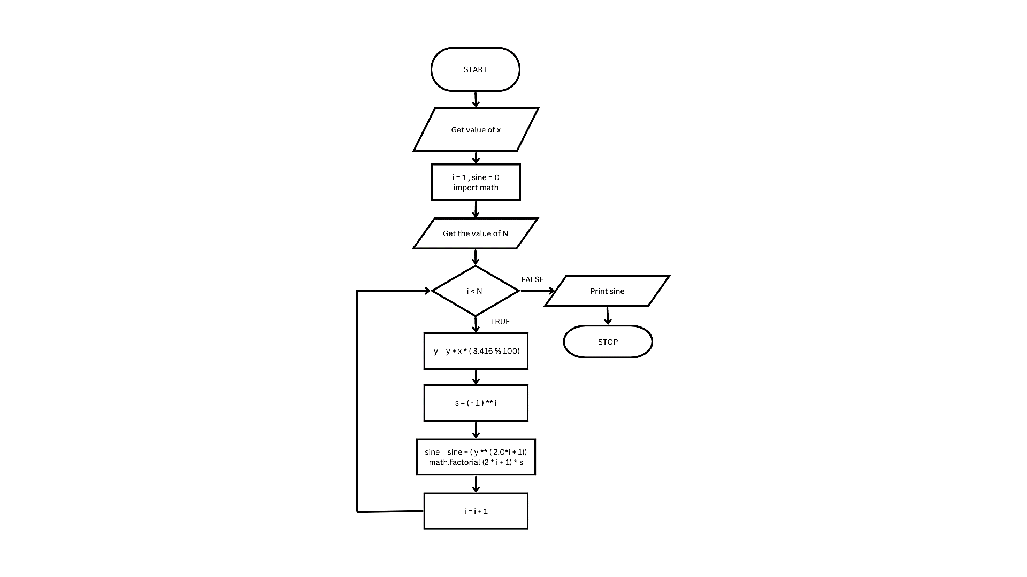

**PSEUDO CODE:**

BEGIN

GET the value of x.

INITIALIZE the values of 1=1, sine =0 and import moth.

GET the value of N.

IF i less than N

CONVERT a to radians and adding it to y.

LET value of s be (-1) to the power i

CALCULATE the series using the formula.

Sine = sine + ((y**2* i +1))/ math factorial (21+4) S.

INCREMENT value of i by 1.

ELSE display sine.

END

**RESULT:**

Thus, the flowchart and the algorithm is written for the problem

**FLOWCHART:**

* Flowchart A graphical representation of the logic for the problem solving.
* The purpose of the flowchart is making the logic of the program in a visual representation
* Flowcharts is a diagram made up of boxes, diamonds, and other shapes, connected by arrows.
* Each shape represents a step-in process and arrows show the order in which they occur.

|  |  |
| --- | --- |
|  | OVAL – TERMINAL SYMBOL |
|  | Parallelogram - Input/ Output symbol |
|  | Rectangle - Process symbol |
|  | Diamond - Decision symbol |
|  | Arrow lines - Flow lines |
|  | To represent a function |
|  | Circle - Connector |

**TOOLS USED TO DRAW FLOWCHART**

1. **Smart Draw –** A good tool to draw and understand but can’t save the file in system it can be used for free up to 7 days after that we must pay to use it.
2. **Canva –** A user-friendly tool which allows the user to view in mobile using the application and can be saved in any format. Without even subscription all the features were available.
3. **App.Diagrams.net -** The diagrams can be saved and also at any destination you want it to be. But the Output Wasn’t precise and not in single page the saved diagrams open up to the website.
4. **Lucidchart -** The diagrams can be directly stored into the system and has all the features and also easy to use. It is required to be paid after some uses .
5. **Visme –** The tool is used for flowchart animation and content creating and in teaching, but more tools are available when you pay for them.
6. **Zenflowchart –** The diagrams can be directly stored into the system and has all the features and also easy to use. But it restricts to use more than 20 shapes on using the 21st shape it must be paid.
7. **Visual Paradiagram –** Visual paradiagram is explicitly designed for flowchart drawing, it is also paid one to use but in complex algorithm cases it is the best
8. **Creatly –** This tool is used to design Unified Modeling Language (UML) and flowcharts.
9. **Google Draw –** All the features are available and they are directly stored in the Google Drive. It should be logged in using Email. But the page size was limited also typing the algorithm wasn’t comfortable.